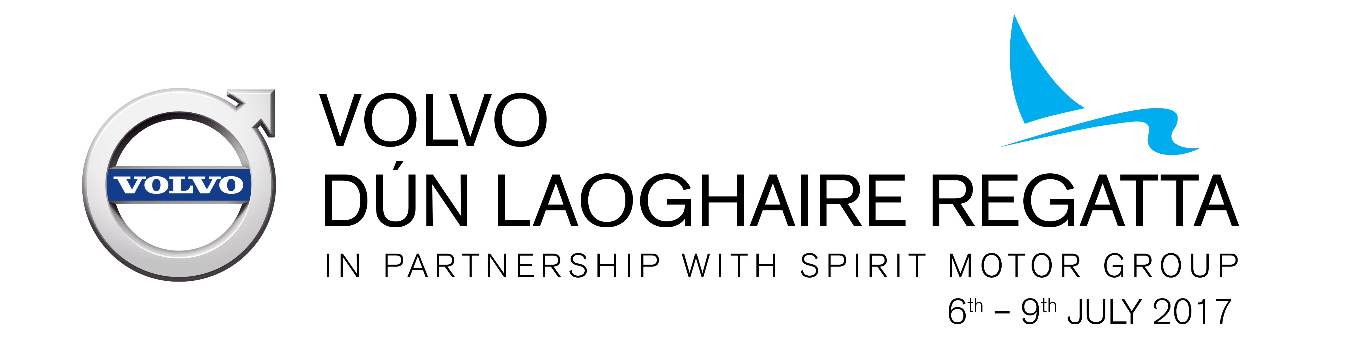

Volvo Dun Laoghaire Regatta 2017

Change to Notice of Race No.1

Removal of separate J109 Class racing

At the request of the class association, J109s shall race in the Cruiser Classes (IRC & ECHO) rather than separately as published in the Notice of Race.

Therefore mention of J109s in the Notice of Race Paragraphs 3.1 (list of classes eligible for entry), 4.1(entry fees table) & 6 (Ratings and /Handicaps) are removed.

J109s who wish to sail in the regatta should enter either the Cruiser Classes (IRC & ECHO) or the IRC Offshore Class.

Change to Notice of Race No.2

Addition of Mixed Sportsboats class to the list of classes

(a) Notice of Race Paragraph 3.1 is changed to include Mixed Sportboats and the following note (f): MIXED SPORTSBOATS shall be provided with handicaps as outlined in the Dublin Bay Sailing Club Sportboats website http://www.dbsportboats.com/sportboat-definition; The entry fee in Paragraph 4.1 for Mixed Sportsboats shall be €225/160.


Con Murphy
Director of Racing
Volvo Dun Laoghaire Regatta 2017

